**CUCUMBER WITH JENKINS**

**Step definition**

**package** StepDefinitions;

**import** org.openqa.selenium.By;

**import** org.openqa.selenium.WebDriver;

**import** org.openqa.selenium.chrome.ChromeDriver;

**import** io.cucumber.java.en.Given;

**import** io.cucumber.java.en.Then;

**import** io.cucumber.java.en.When;

**public** **class** StepDefinition {

WebDriver driver =**null**;

@Given("the user opens the browser")

**public** **void** the_user_opens_the_browser() {

System.*setProperty*("webdriver.chrome.driver","C:\\Users\\ustjavasdetb411\\Desktop\\chromedriver.exe" );

driver = **new** ChromeDriver();

driver.manage().window().maximize();

}

@When("the user navigates to google")

**public** **void** the_user_navigates_to_google() {

driver.get("https://www.google.com");

}

@Then("search aluva")

**public** **void** search_aluva() {

driver.findElement(By.*xpath*("/html/body/div[1]/div[3]/form/div[1]/div[1]/div[1]/div/div[2]/input")).sendKeys("Aluva");

}

}

**Test Runner**

**package** StepDefinitions;

**import** org.junit.runner.RunWith;

**import** io.cucumber.junit.Cucumber;

**import** io.cucumber.junit.CucumberOptions;

@RunWith(Cucumber.**class**)

@CucumberOptions(features="src/main/resources/Features",glue= {"StepDefinitions"},

monochrome=**true**)

**public** **class** TestRunner {

}

**Feature File**

Feature: This test the google website

Scenario: Test the google search page

Given the user opens the browser

When the user navigates to google

Then search aluva

**POM File**

<project xmlns=*"http://maven.apache.org/POM/4.0.0"*

xmlns:xsi=*"http://www.w3.org/2001/XMLSchema-instance"*

xsi:schemaLocation=*"http://maven.apache.org/POM/4.0.0 https://maven.apache.org/xsd/maven-4.0.0.xsd"*>

<modelVersion>4.0.0</modelVersion>

<groupId>Cucumber_Test</groupId>

<artifactId>Cucumber_Test</artifactId>

<version>0.0.1-SNAPSHOT</version>

<dependencies>

<dependency>

<groupId>org.seleniumhq.selenium</groupId>

<artifactId>selenium-java</artifactId>

<version>2.47.1</version>

</dependency>

<dependency>

<groupId>io.cucumber</groupId>

<artifactId>cucumber-java</artifactId>

<version>5.7.0</version>

</dependency>

<dependency>

<groupId>io.cucumber</groupId>

<artifactId>cucumber-junit</artifactId>

<version>5.7.0</version>

</dependency>

<dependency>

<groupId>junit</groupId>

<artifactId>junit</artifactId>

<version>4.13</version>

</dependency>

</dependencies>

</project>

**Steps**

* Create New item as Cucumbertest 🡪 click Maven project 🡪 Ok
* Manage Jenkins 🡪 Manage Plugins 🡪 install the following:

Maven Integration,

Cucumber,

Cucumber Trend Report,

Cucumber Report

* Take the project(Cucumbertest) 🡪 configure 🡪 paste the pom root in the build environment

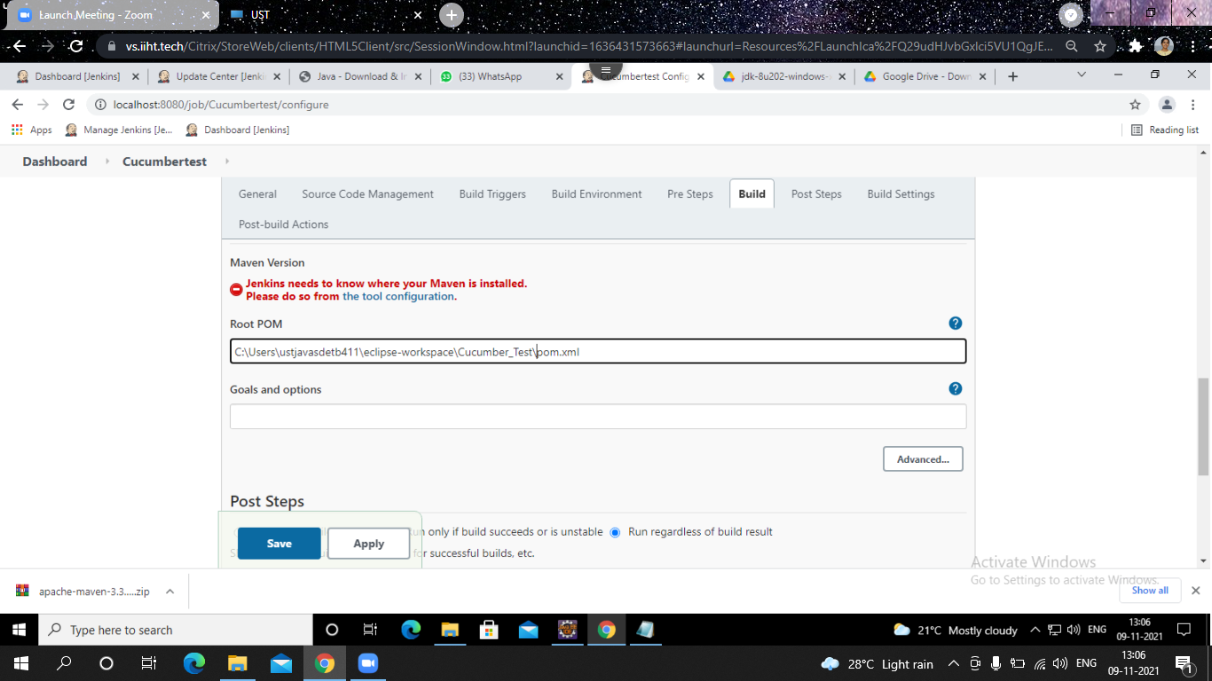

* Manage Jenkins 🡪 Global tool configuration 🡪 give the JDK path 🡪Then add maven and give its path also (path of that apache-maven-3.3.1 zip file) 🡪 Then save & apply

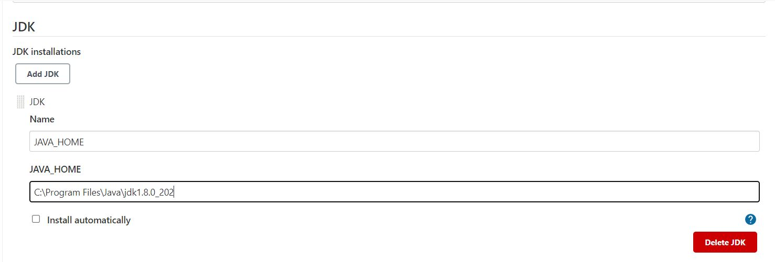

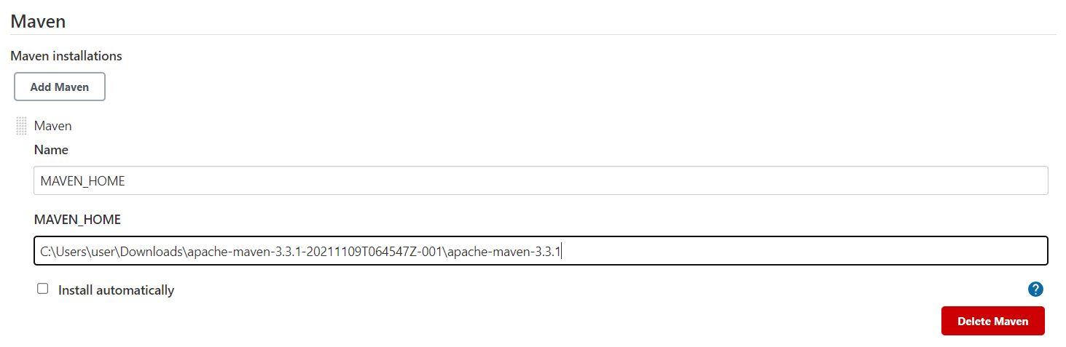

* Select the project 🡪 click Build now 🡪 click on the #1 🡪 then click Console output



